

2nd Year 2nd Semester BSc. (Hons) Final Examination 2018-2019

# Institute of Information Technology Jahangirnagar University

Savar, Dhaka-1342

ICT 2204: Database Management System Lab

***JU Medical Management System***

**Submitted To:**

**Manan Binth Taj Noor**

Lecturer

Institute of Information Technology

Jahangirnagar University

**Submitted By: Group No : 05**

Md. Shakil Hossain (2023) Shariful Islam (2020)

Ashfaqur Rahman Tokee (2022) Amit Azim Amit (2090)

**JU Medical Management System**

# Description:

Jahangirnagar University has its own Medical Centre for the students, the teachers and the staffs. The center provides twenty-four-hour service. It is supervised by the Chief Medical Officer with a staff of qualified doctors. The center bears all expenses related to treatment in case of students. But it provides only health-related advice in case of the teachers and the staff.

There are 12 doctors, 20 staffs to maintain the medical center and serve the students and teachers. Here the authority offers the free treatment, medicine and suggestions to the students but there is no accommodation for serious patients.

Our goal of this project is to create a database to manage this center digitally. We want to list all the doctors and patients in a database and keep track of appoints, treatments, medication etc. Which will improve student’s overall health and hopefully save time and resources for Medical center.

# Scenario:

With this project, we can store information of Doctors, Patients and staffs working in JU Medical Center. We can also track available beds, tests done in the hospital, Ambulance and Medicines.

In the hospital, Each Doctor has a unique id **(D_ID)**, name **(Name)**, gender **(Gender)** and working day **(Work day)** stored in the database. Each doctor attends patient based on their specialty **(Specialty)**. Each patient has a unique id **(P_ID)**, name **(P_name)**, gender **(Gender)**, age **(Age)** and either the patient is a teacher or student**(P_type)**. Patients can get tests in the center if necessary. Each test has a unique test id**(T_ID)** and a name**(T_name)**. Tests are governed by staffs. They have a staff id**(S_ID)**, name**(S_name)**, gender**(Gender)** and working day**(Work day)** stored in the database. Patients also receives medicine which has a medicine code**(M_code)** and quantity**(Quantity)**. Doctor can also admit patient to beds that has bed number**(Bed number)**. We will also keep track if the bed is available or not**(Bed Status)**. Serious patients can also be referred to other hospital using ambulance. Each Ambulance has a ambulance number**(Amb_ID)** and we will also track if that ambulance is present or not**.(Amb status)**.

## ER Diagram

D_Name

Gender

Work Day

Attends

D_ID

(0, n)

Doctor

(0, n)

Specialty

Gender

S_Name

Work Day

P_Name

Gender Age

(1, n)

P_Type

has

S_ID

(0, n)

Staff

P_ID

Assigned

(0, 1)

Patient

(0, 1)

Referred to

(0, n)

(0, n)

Take

(0, n)

T_name

T_ID

Tests

(1, 1)

(1, n)

Governs

Receives

Bed

(0, 1)

(0, 1) (0, n)

Ambulance Medicine

Quantity

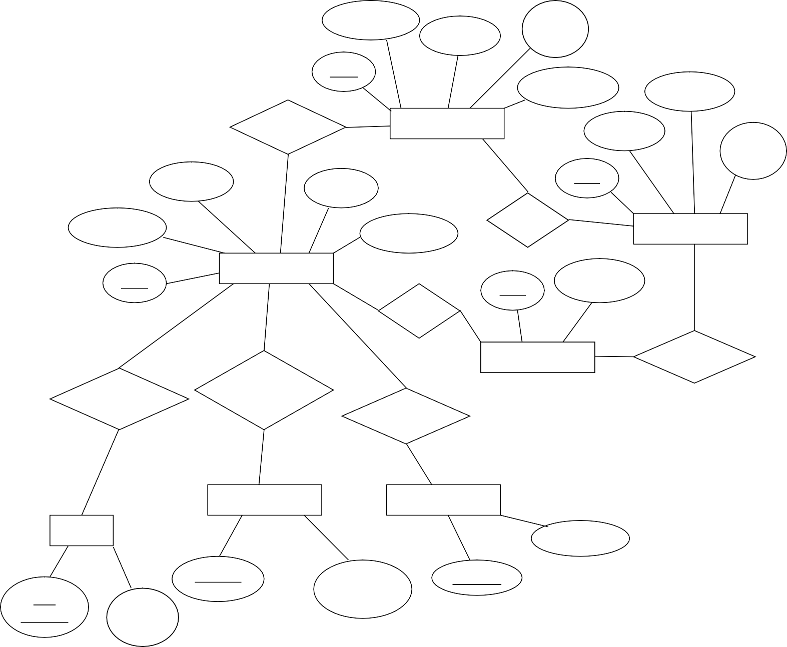

Bed Number

Bed Status

Amb_ID Amb

Status

M_Code

## Schema Diagram

Doctor( D_ID, D_Name, Gender, Work day, Speciality ).

Patient( P_ID, P_Name, Gender, Age, P_Type).

Doc_Patient( D_ID, P_ID).

Staff( S_ID, S_Name, Gender, Work day, T_ID ).

Doc_Staff( D_ID, S_ID ).

Test( T_ID, T_Name ).

Patient_takes_test ( P_ID, T_ID ).

Bed( Bed_Num, Bed_Status, P_ID ).

Ambulence (Amb_ID, Amb_Status, P_ID).

Medicine(M_Code, Quantity ).

Patients_Recieves( P_ID, M_Code).